WEEK4 FINAL PROJECT
MILESTONE 1
@NETWORKWALKS
@WAQASKARIM
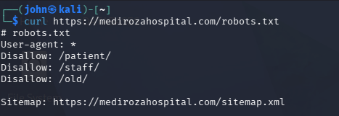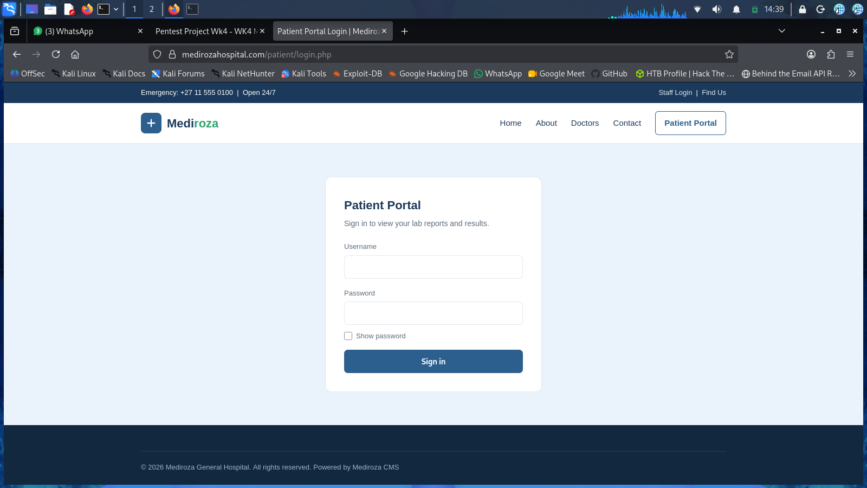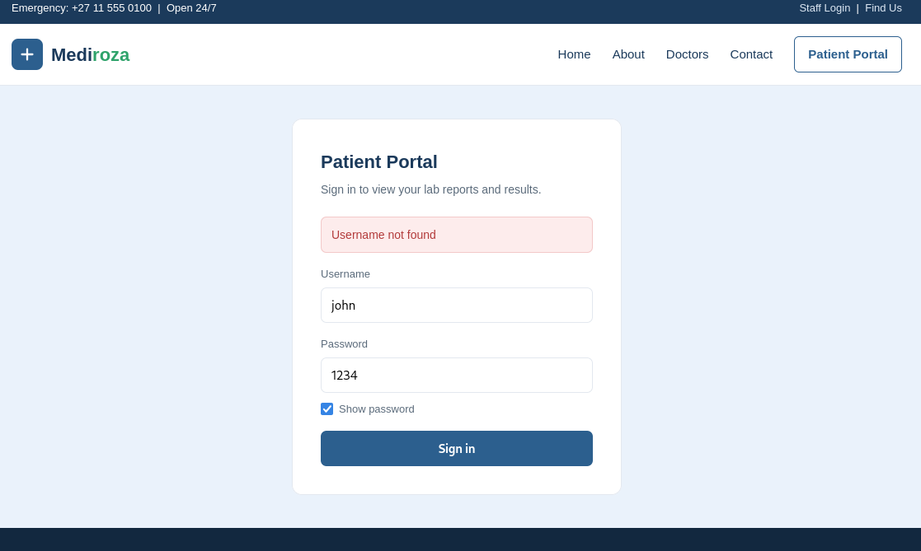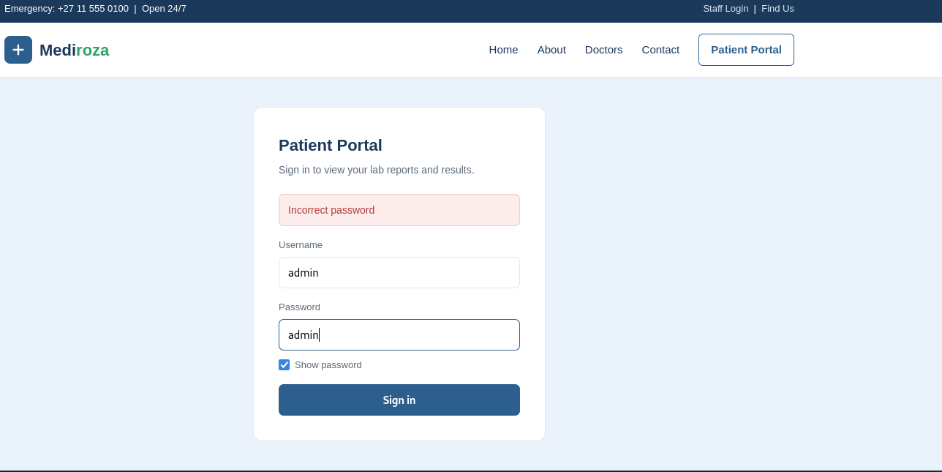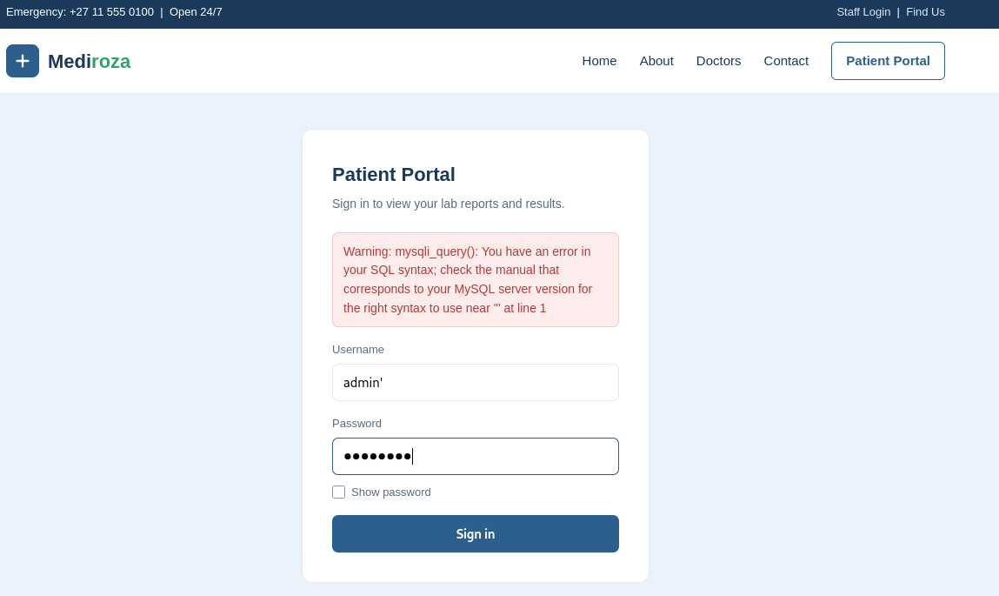

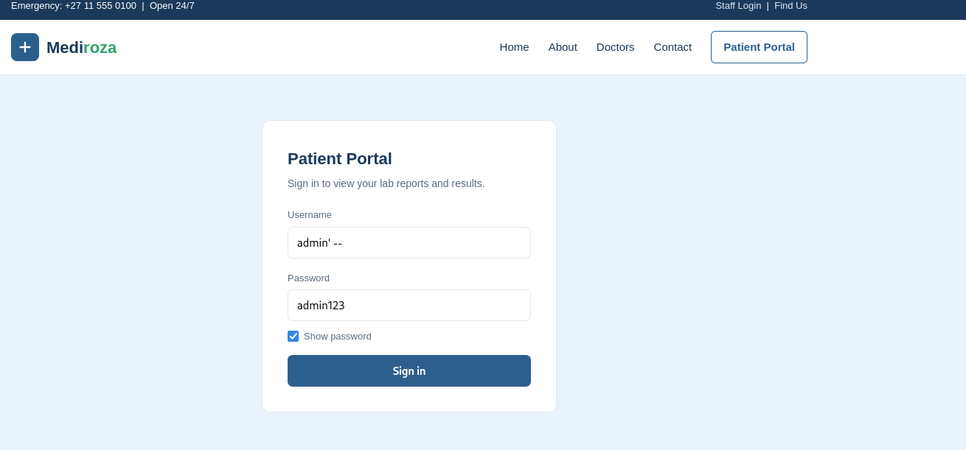

MILESTONE 2
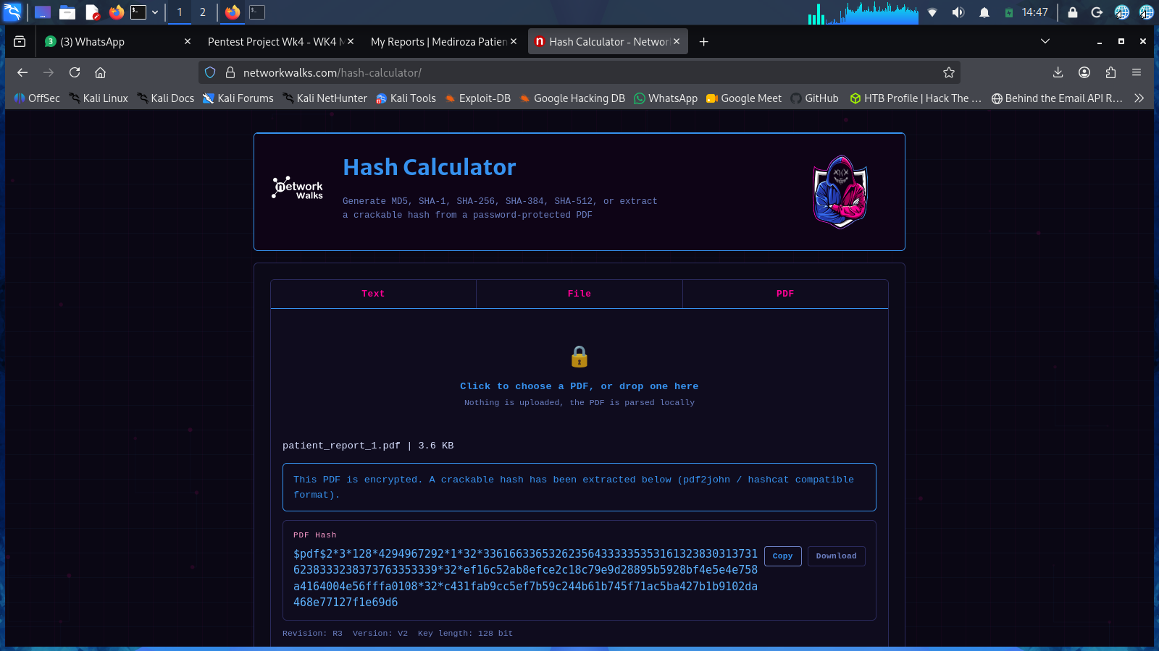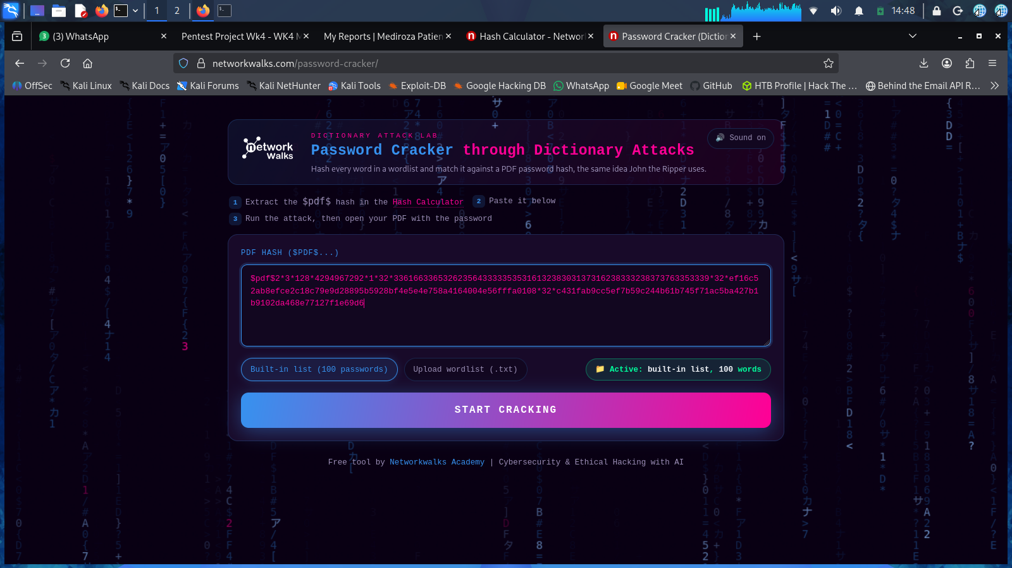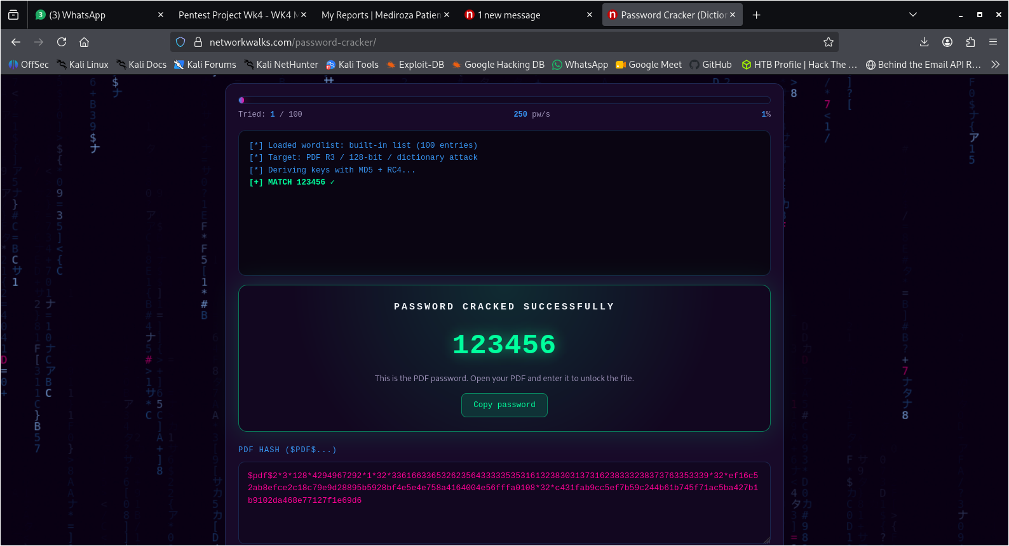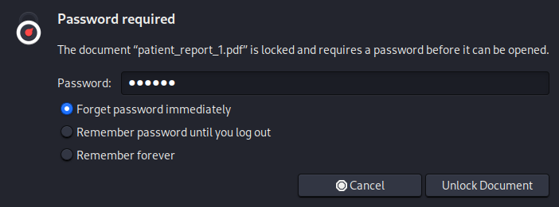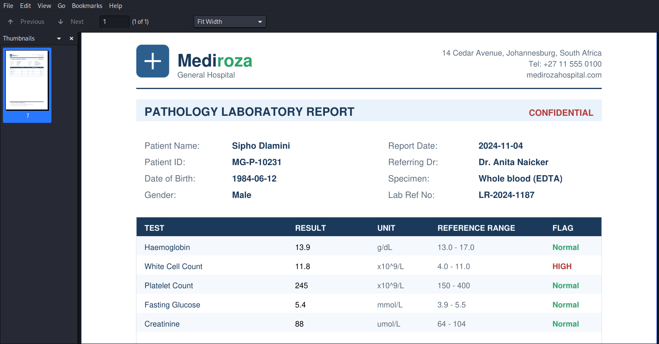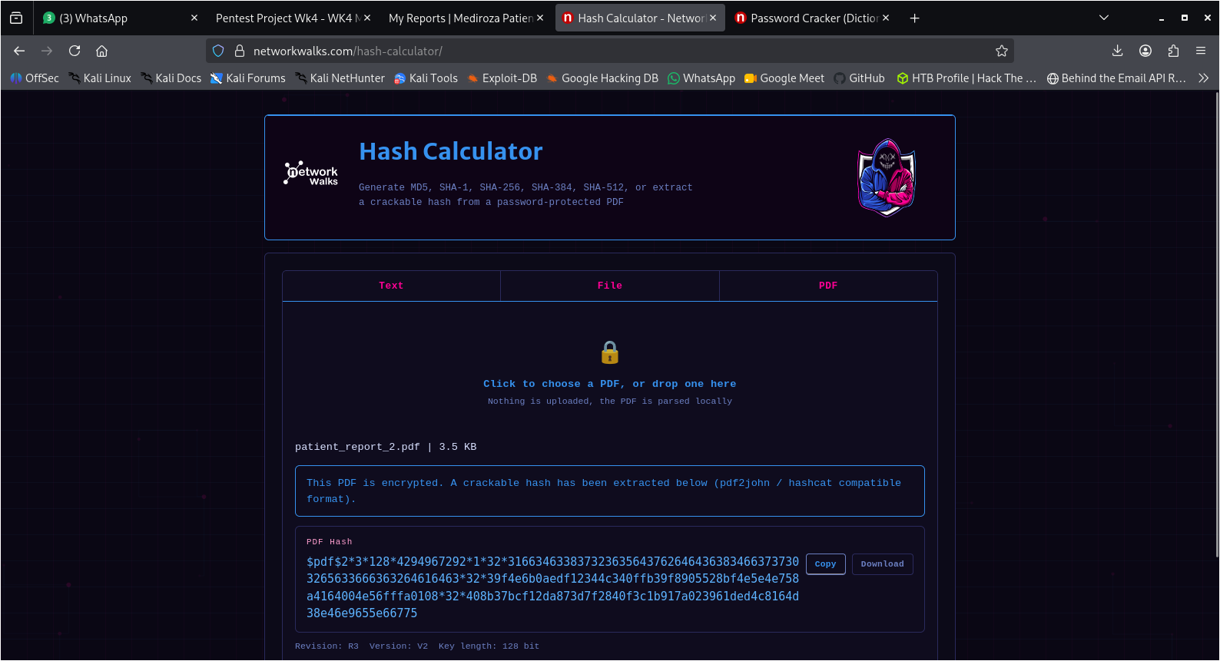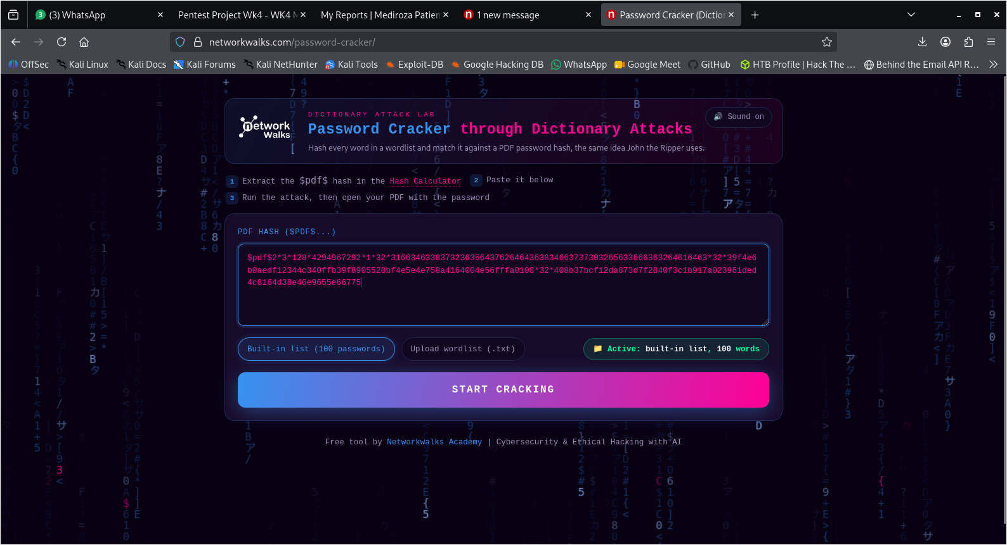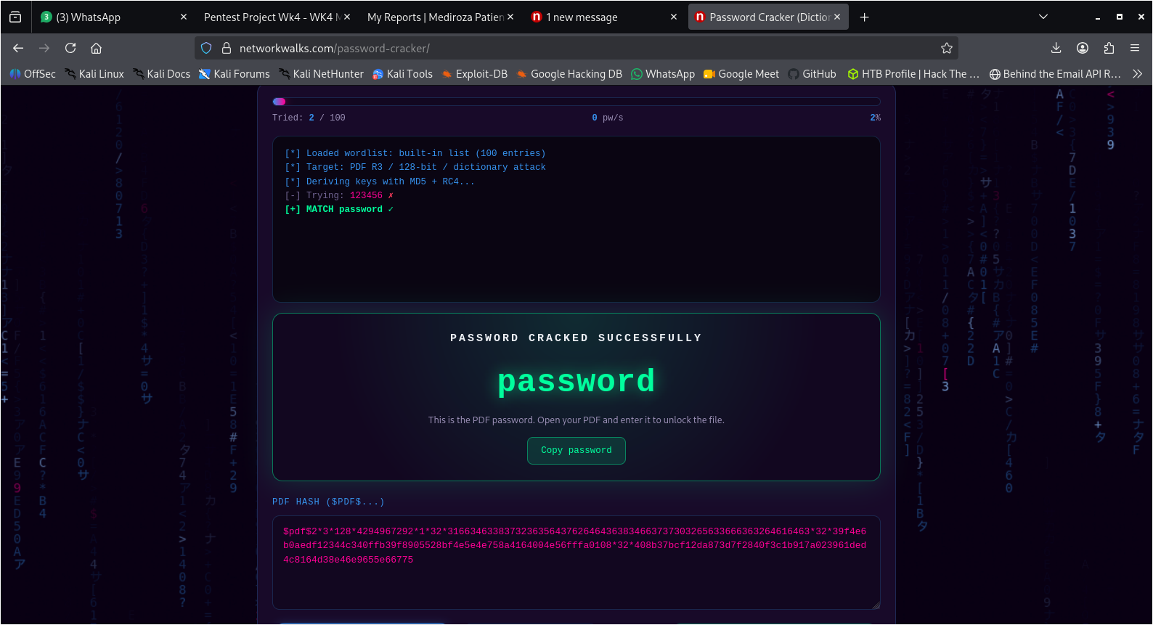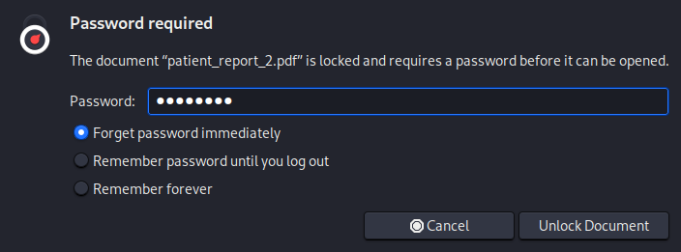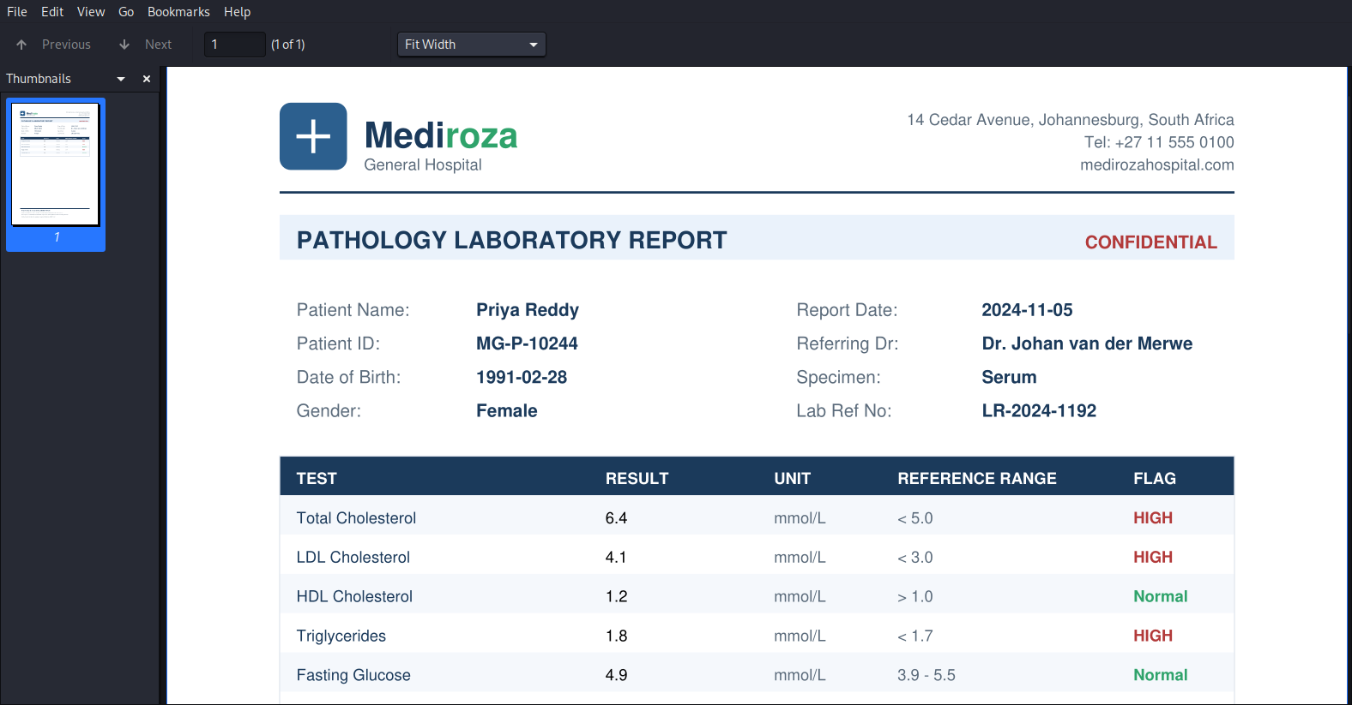

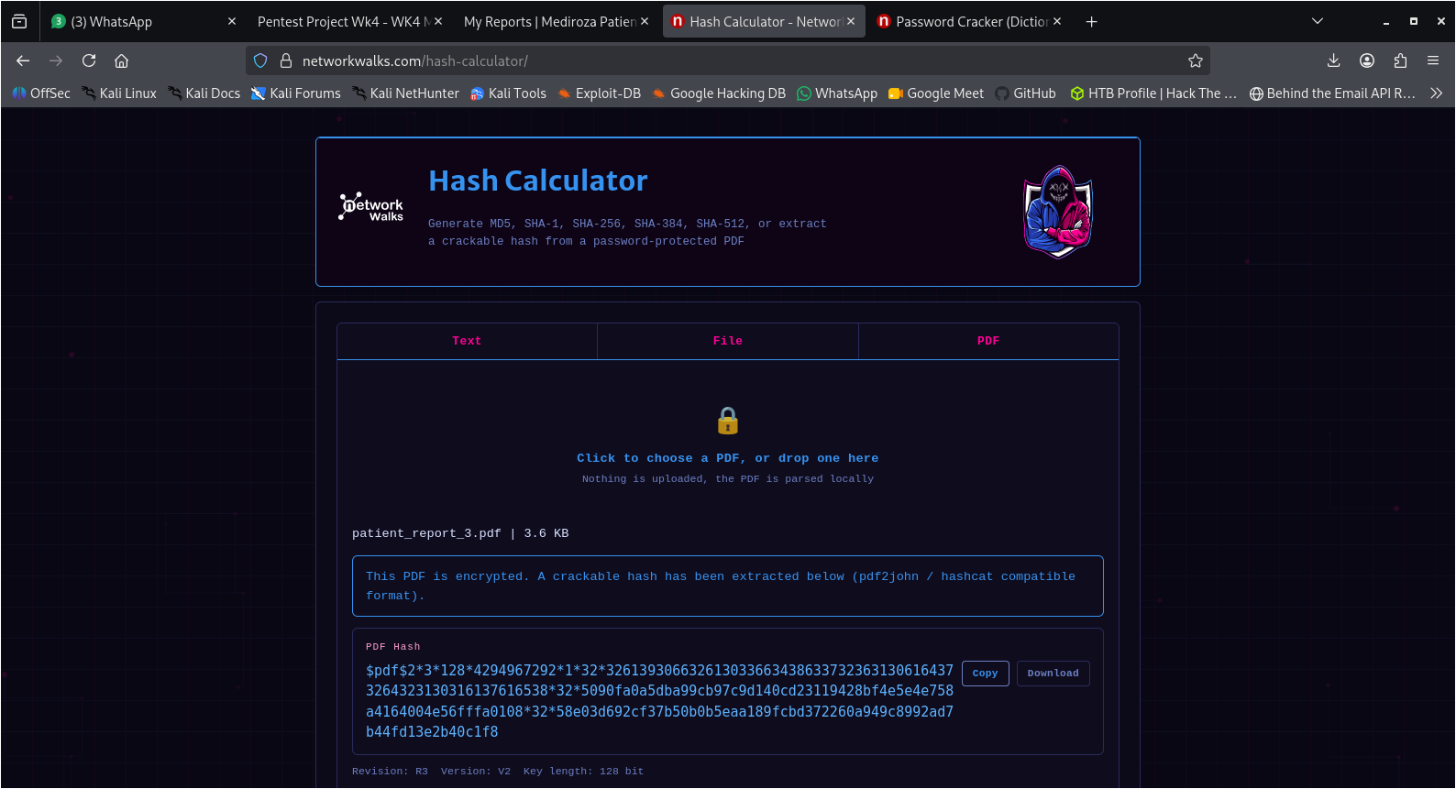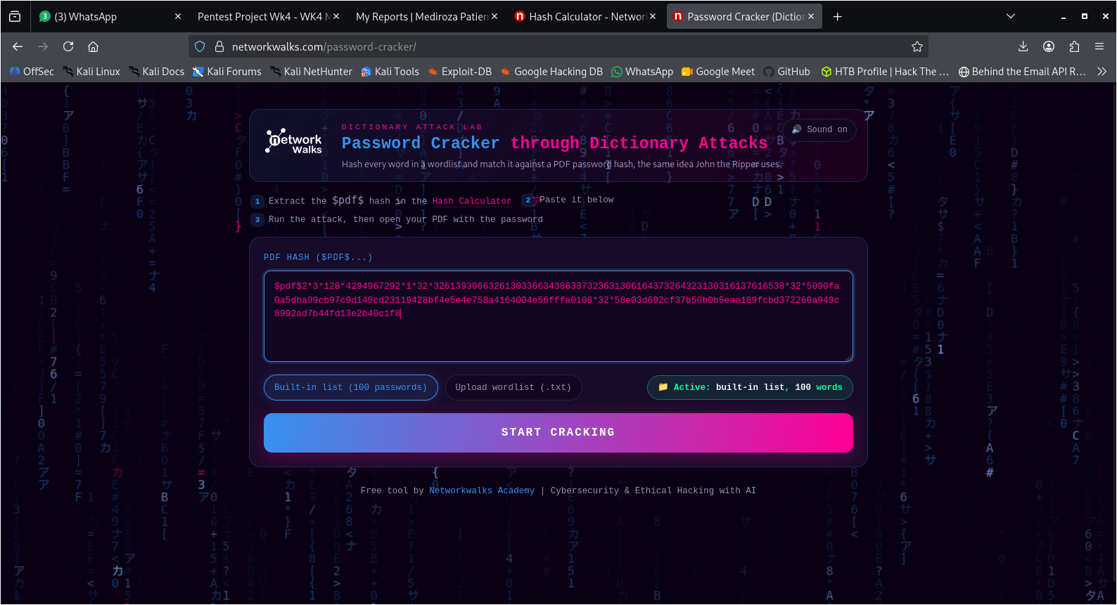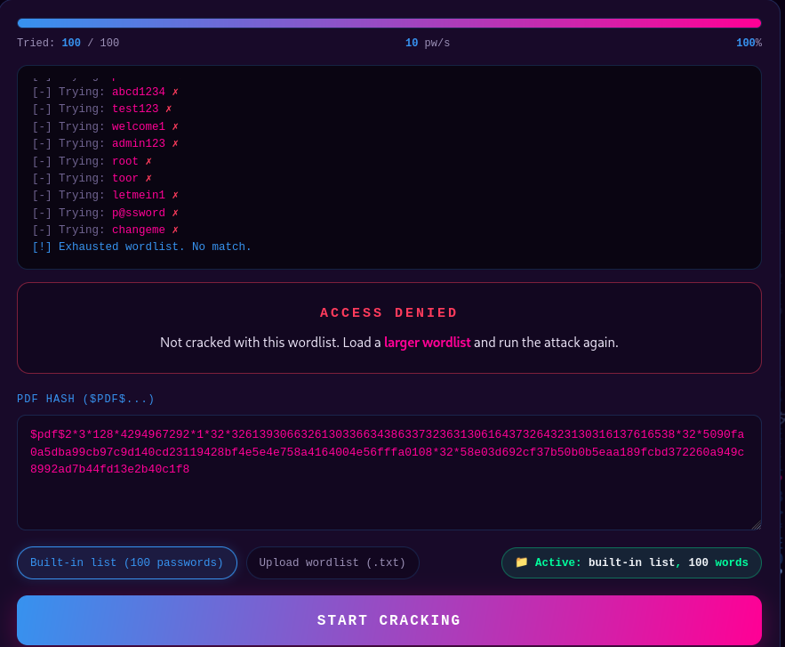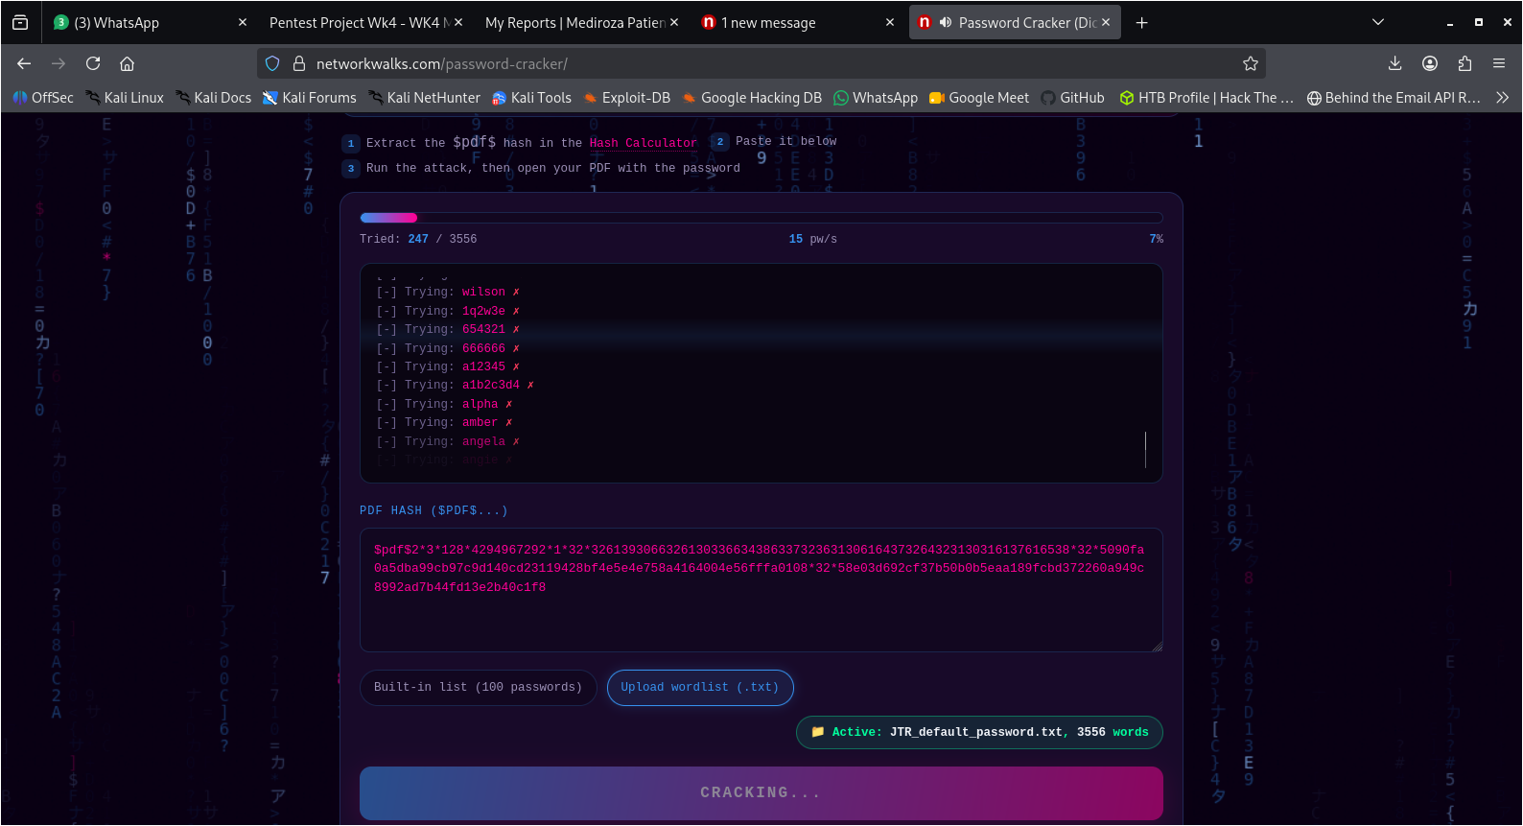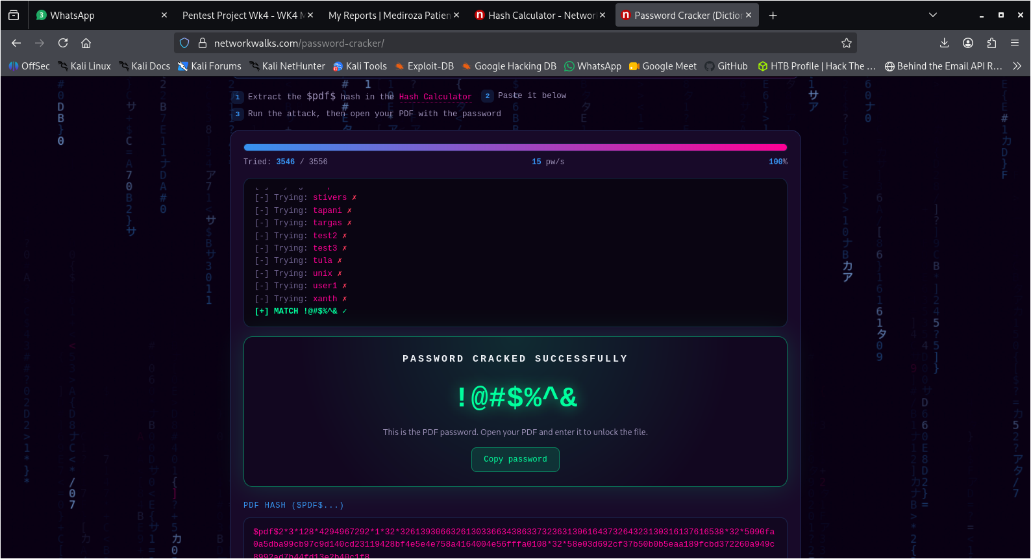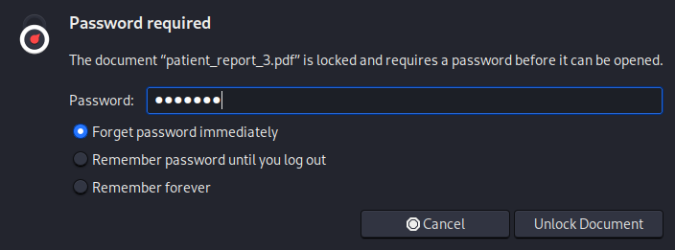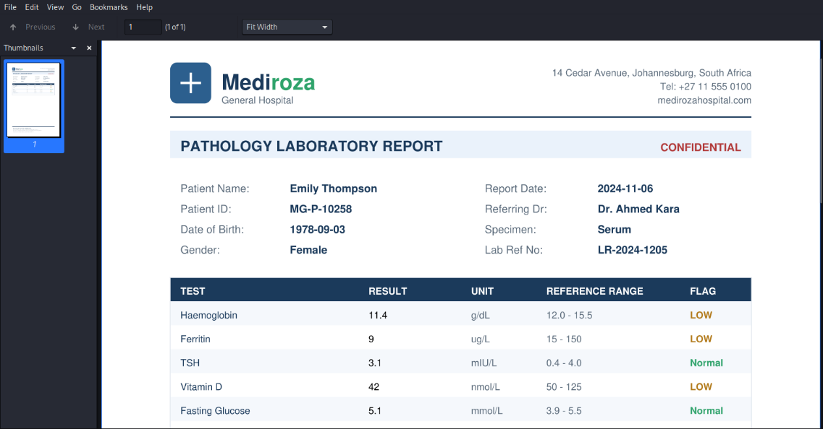
MILESTONE 3

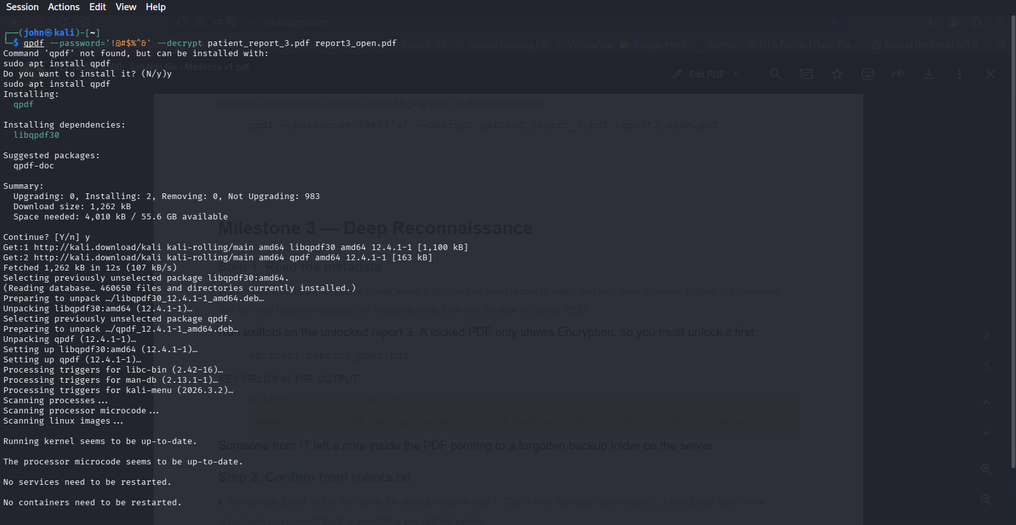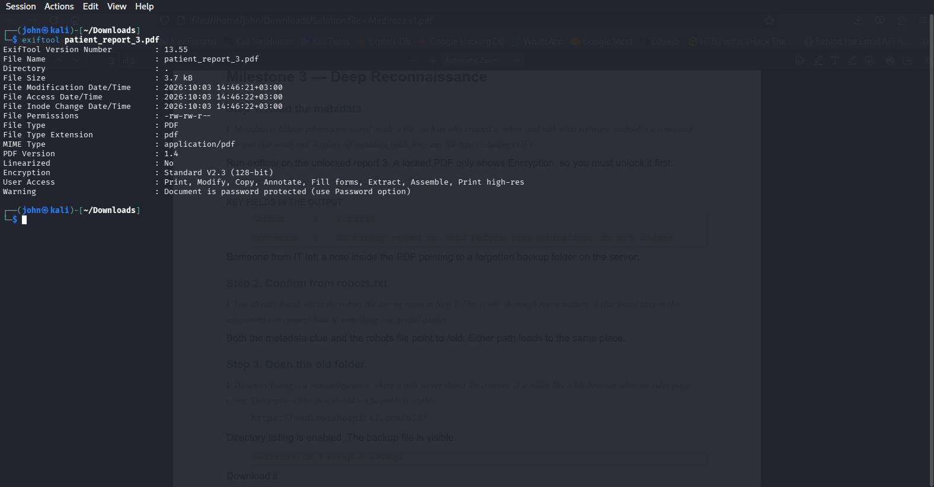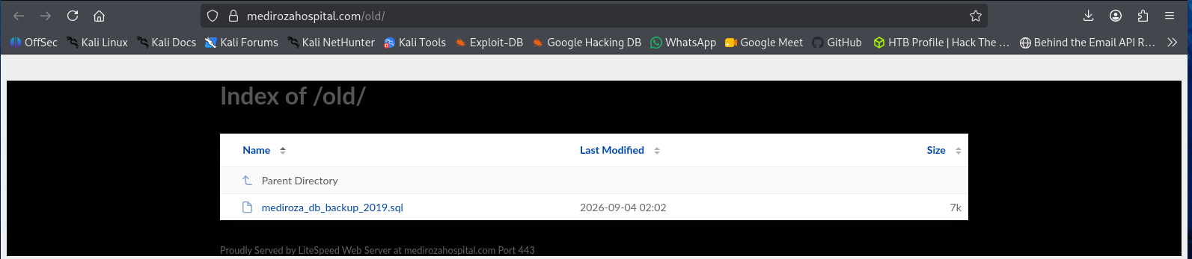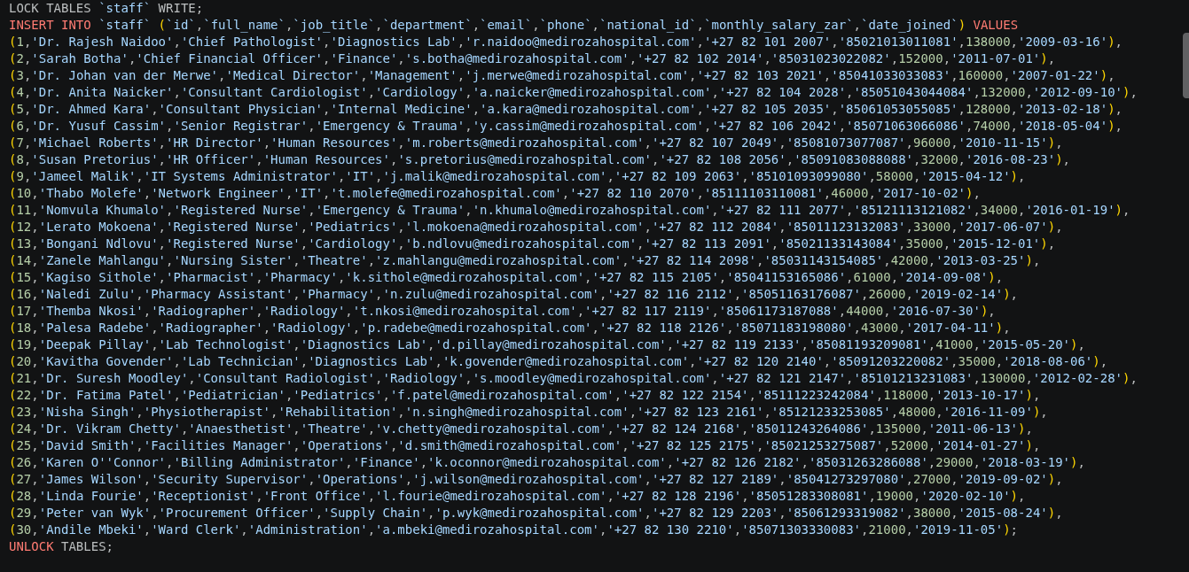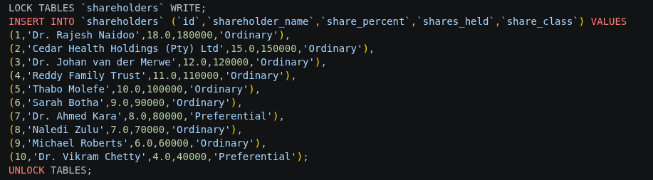
STAFF TABLE
Full Name | Job Title | Department | Monthly Salary (ZAR)
Dr. Rajesh Naidoo | Chief Pathologist | Diagnostics Lab | R 138,000
Sarah Botha | Chief Financial Officer | Finance | R 152,000
Dr. Johan van der Merwe | Medical Director | Management | R 160,000
Dr. Anita Naicker | Consultant Cardiologist | Cardiology | R 132,000
Dr. Ahmed Kara | Consultant Physician | Internal Medicine | R 128,000
Dr. Yusuf Cassim | Senior Registrar | Emergency & Trauma | R 74,000
Michael Roberts | HR Director | Human Resources | R 96,000
Susan Pretorius | HR Officer | Human Resources | R 32,000
Jameel Malik | IT Systems Administrator | IT | R 58,000
Thabo Molefe | Network Engineer | IT | R 46,000
Nomvula Khumalo | Registered Nurse | Emergency & Trauma | R 34,000
Lerato Mokoena | Registered Nurse | Pediatrics | R 33,000
Bongani Ndlovu | Registered Nurse | Cardiology | R 35,000
Zanele Mahlangu | Nursing Sister | Theatre | R 42,000
Kagiso Sithole | Pharmacist | Pharmacy | R 61,000
Naledi Zulu | Pharmacy Assistant | Pharmacy | R 26,000
Themba Nkosi | Radiographer | Radiology | R 44,000
Palesa Radebe | Radiographer | Radiology | R 43,000
Deepak Pillay | Lab Technologist | Diagnostics Lab | R 41,000
Kavitha Govender | Lab Technician | Diagnostics Lab | R 35,000
Dr. Suresh Moodley | Consultant Radiologist | Radiology | R 130,000
Dr. Fatima Patel | Pediatrician | Pediatrics | R 118,000
Nisha Singh | Physiotherapist | Rehabilitation | R 48,000
Dr. Vikram Chetty | Anaesthetist | Theatre | R 135,000
David Smith | Facilities Manager | Operations | R 52,000
Karen O'Connor | Billing Administrator | Finance | R 29,000
James Wilson | Security Supervisor | Operations | R 27,000
Linda Fourie | Receptionist | Front Office | R 19,000
Peter van Wyk | Procurement Officer | Supply Chain | R 38,000
Andile Mbeki | Ward Clerk | Administration | R 21,000

SHAREHOLDERS TABLE
Shareholder Name | Share Percentage | Share Class
Dr. Rajesh Naidoo | 18.00% | Ordinary
Cedar Health Holdings (Pty) Ltd | 15.00% | Ordinary
Dr. Johan van der Merwe | 12.00% | Ordinary
Reddy Family Trust | 11.00% | Ordinary
Thabo Molefe | 10.00% | Ordinary
Sarah Botha | 9.00% | Ordinary
Dr. Ahmed Kara | 8.00% | Preferential
Naledi Zulu | 7.00% | Ordinary
Michael Roberts | 6.00% | Ordinary
Dr. Vikram Chetty | 4.00% | Preferential

